**Scenario: You have submitted a paper to a conference and you have gotten the comments. You need to know the comments about “communication” in your paper, and you want to see what part of paper was mostly.**

**We have made a system that extracts information of articles and allows analysis based on them. We want to compare directly checking the paper reviews and the output of analysis of the extracted information.**

Please do these two tasks then answer the questionnaire.

**TASK** 1.

1. **checkout comments performed by Reviewer2 about “communication” and say that comment was too general?**

1. Using this link <https://afshin.databox.me/public/Article1.html#2987879860>
2. Using the an automatic system that searches the word comment between comments and shows the response shown below this image

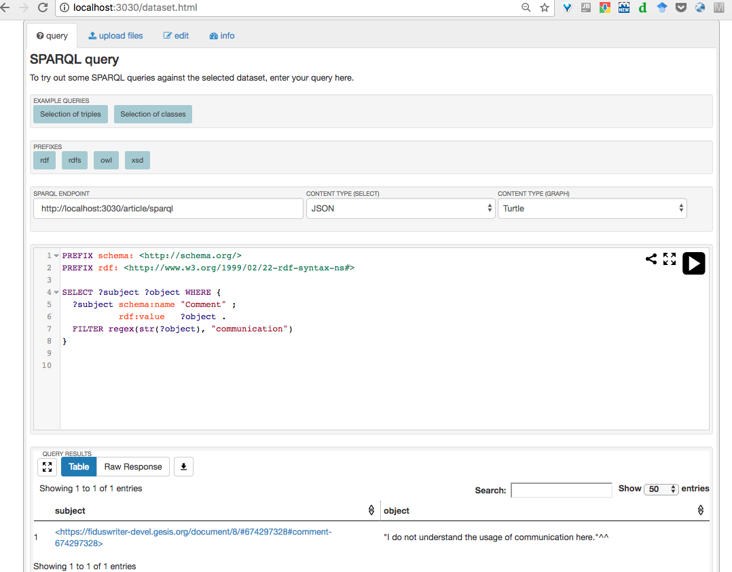

**TASK** 2.

**2. Find out the most commented section in the article.**

1. Using this link <https://afshin.databox.me/public/Article1.html#2987879860>
2. Using the result of the analysis shown below this image

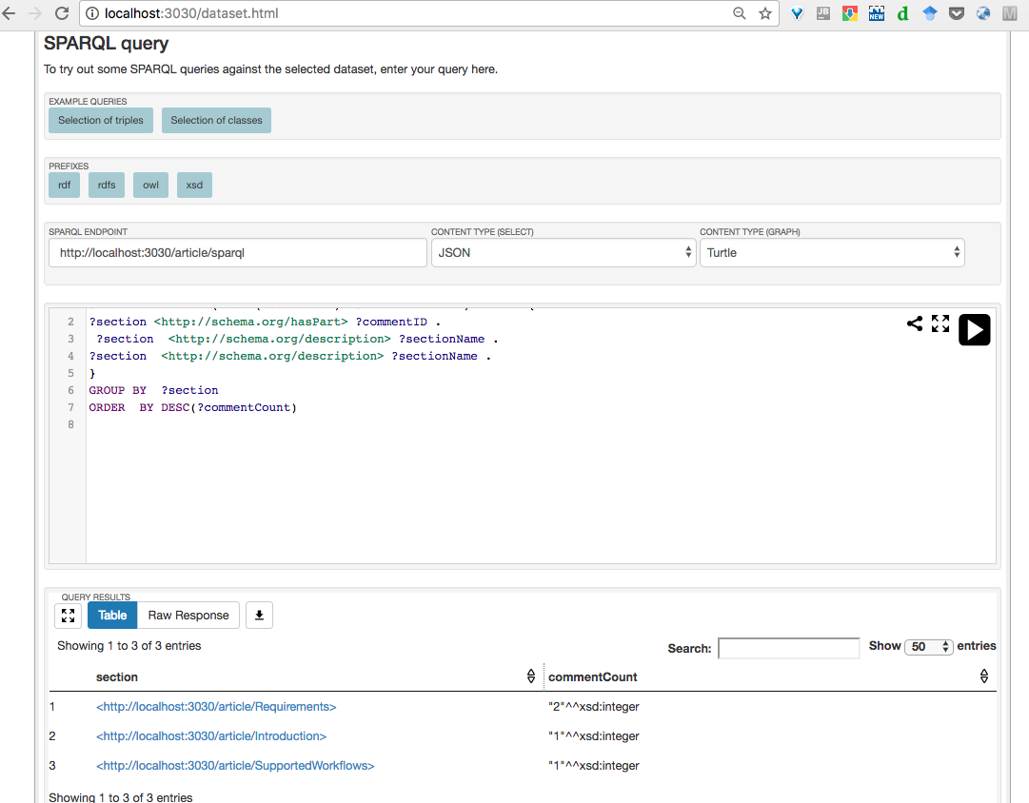

**Overall reaction to the system**

1. Between 1. **terrible** to 9. **wonderful** what point do you give. 5
2. Between 1. **difficult** to 9. **easy** what point do you give. 8
3. Between 1. **frustrating** to 9. **satisfying** what point do you give. 9
4. Between 1. **Inadequate** **power** to 9. **adequate** **power** what point do you give. 8
5. Between 1. **dull** to 9. **stimulating** what point do you give. 4
6. Between 1. **rigid** to 9. **flexible** what point do you give. 6

**Learning**

1.Have you ever reviewed a paper? yes

2. Learning required to do the task? no

3. Did it required remembering the names and use of commands? no

4.Performing tasks is straightforward? yes

5.does it need supplemental reference materials? no

**System Capabilities**

6.System speed in comparison to check the reviewed paper? Match faster

7.System reliability? Seems so

8.System tends to be? Helping in checking my review

9.Correcting your mistakes or do less mistake?yes especially for long papers

10. Designed for all levels of users? yes

List of the most Negative aspects?



List of the most Positive aspects?

1. Help in getting info , would be nice if more queries were available